SECURITIES AND EXCHANGE COMMISSION

Washington, D.C. 20549

SCHEDULE 14D-9

Solicitation/Recommendation Statement

under Section 14(d)(4) of the Securities Exchange Act of 1934

COMSCORE, INC.

(Name of Subject Company)

COMSCORE, INC.

(Name of Person(s) Filing Statement)

Common Stock, par value $0.001 per share

(Title of Class of Securities)

20564W105

(CUSIP Number of Class of Securities)

Christiana L. Lin, Esq.

General Counsel and Chief Privacy Officer

comScore, Inc.

11950 Democracy Drive. Suite 600

Reston, Virginia 20190

703 438-2000

(Name, address and telephone number of person authorized to receive notices and communications on behalf of the person(s) filing statement)

 | With copies to:
Robert G. Day, Esq. | Michael Labriola, Esq.
Wilson Sonsini Goodrich & Rosati | Wilson Sonsini Goodrich & Rosati
Professional Corporation | Professional Corporation
650 Page Mill Road | 1700 K Street, NW, Fifth Floor
Palo Alto, CA 94304 | Washington, DC 20006
(650) 493-9300 | (202) 973-8800

- Check the box if the filing relates solely to preliminary communications made before the commencement of a tender offer.

This Schedule 14D-9 filing consists of the following communications relating to the proposed tender offer by WPP plc (“WPP”) for up to 15% the outstanding shares of comScore, Inc. (“comScore”): (i) a press release announcing certain transactions between comScore and WPP and its affiliates; (ii) a presentation for comScore’s conference call regarding its fourth quarter and full year 2014 financial results at 8:30 a.m. on February 12, 2015; and (iii) a transcript of that conference call.

-2-



FOR IMMEDIATE RELEASE | Contacts: |  | Andrew Lipsman
 |  |  | comScore, Inc.
 |  | 312-775-6510
 |  | press@comscore.com
 |  |  | Lindsay McMurdo
 |  |  | Kantar
 |  | +44 207 6565486
 |  | Lindsay.mcmurdo@kantar.com
 | comScore and Kantar Announce Strategic Global Partnership
 | to Accelerate Cross-Media Audience and Campaign Measurement

Kantar Parent WPP Takes Equity Stake in comScore

RESTON, VA, and LONDON, UK, February 12, 2015 – comScore (NASDAQ: SCOR) today announced a strategic alliance with WPP’s data investment management division, Kantar. The alliance, which covers territories outside the U.S., establishes a framework for the parties to bring the best of breed together from the two companies – their products, technology, data assets, research panels and relationships – to provide world class cross-media audience and campaign measurement capabilities.

The alliance follows the intended acquisition by WPP, announced earlier today, of a substantial equity stake in comScore. Under the terms of the agreement, comScore will issue 4.45% in shares in exchange for the benefits of the strategic alliance, and acquisition of certain European Internet audience measurement assets. WPP will also purchase up to 15% shares of comScore through a tender offer with an offering price of $46.13, giving WPP a total ownership stake in comScore of between 15-20%. The transaction is subject to customary regulatory approvals and is expected to close in the second quarter of 2015. Provided WPP’s tender offer is successful, it is expected to be accretive to comScore’s non-GAAP earnings per share in 2015.

comScore will partner with Kantar and its operating businesses on cross-media audience and campaign measurement in non-U.S. markets. comScore will also acquire the assets of Kantar’s Internet audience measurement businesses in certain European markets. In these markets, Kantar and comScore will continue to provide the same level of seamless integration and data services.

“This long-term, strategic alliance will simplify the deployment of global measurement capabilities and accelerate the creation of new services for the industry. The emerging mediascape points to a massive global opportunity waiting to be unlocked by cracking the code on cross-media audience and campaign measurement,” said comScore CEO Serge Matta. “We look forward to working together with Kantar to deliver new measurement products based on our complementary offerings in these markets.”

Kantar CEO Eric Salama commented: “By partnering with comScore and combining our respective strengths, we will integrate data and expertise to give our clients a new standard in measuring audiences and campaigns across multiple platforms. This continues our strategy of combining survey, panel and census data and putting digital at the heart of all we do.”

About comScore

comScore, Inc. (NASDAQ: SCOR) is a global leader in digital measurement and analytics, delivering insights on web, mobile and TV consumer behavior that enable clients to maximize the value of their digital investments. For more information, please visit www.comscore.com/companyinfo.

About Kantar

Kantar is the data investment management arm of WPP and one of the world’s largest insight, information and consultancy groups. By uniting the diverse talents of its 12 specialist companies, the group is the pre-eminent provider of compelling data and inspirational insights for the global business community. Its 30,000 employees work across 100 countries and across the whole spectrum of research and consultancy disciplines, enabling the group to offer clients business insights at every point of the consumer cycle. The group’s services are employed by over half of the Fortune Top 500 companies. For further information, please visit us at www.kantar.com

Additional Information and Where to Find It

The tender offer for up to 15% of the outstanding shares of comScore, Inc. (“comScore”) described herein has not yet commenced. This communication is provided for informational purposes only and is neither an offer to purchase nor a solicitation of an offer to sell any securities of comScore pursuant to the proposed tender offer by WPP plc (“WPP”), or otherwise. Any offers to purchase or solicitations of offers to sell will be made only pursuant to the Tender Offer Statement on Schedule TO (including the offer to purchase, the letter of transmittal and other documents relating to the tender offer) which will be filed with the U.S. Securities and Exchange Commission (“SEC”) by WPP. In addition, comScore will file with the SEC a Solicitation/Recommendation Statement on Schedule 14D-9 with respect to the tender offer. COMSCORE’S STOCKHOLDERS ARE ADVISED TO READ THESE DOCUMENTS, ANY AMENDMENTS TO

THESE DOCUMENTS AND ANY OTHER DOCUMENTS RELATING TO THE TENDER OFFER THAT ARE FILED WITH THE SEC CAREFULLY AND IN THEIR ENTIRETY PRIOR TO MAKING ANY DECISION WITH RESPECT TO ACQUISITION SUB’S TENDER OFFER BECAUSE THEY CONTAIN IMPORTANT INFORMATION, INCLUDING THE TERMS AND CONDITIONS OF THE OFFER. comScore’s stockholders may obtain copies of these documents (when they become available) for free at the SEC’s website at www.sec.gov or from comScore’s Investor Relations department at http://ir.comscore.com.

Cautionary Note Regarding Forward-Looking Statements

This release contains forward-looking statements within the meaning of Section 27A of the Securities Act of 1933 and Section 21E of the Securities Exchange Act of 1934, including, but not limited to, expectations regarding the impact and benefits to comScore and WPP from their partnership, financial or otherwise, and the expected results and outcome of the pending tender offer and transactions. These statements involve risks and uncertainties that could cause our actual results to differ materially, including, but not limited to: the features and characteristics of the products, the rate of development of the digital marketing intelligence, Internet advertising and e-Commerce markets; the growth of the Internet as a medium for commerce, content, advertising and communications; the level of participation by comScore stockholders in the tender offer; and the acceptance of new products and methodologies by the industry, including existing and prospective clients.

For a detailed discussion of these and other risk factors, please refer to comScore’s most recent respective Quarterly Reports on Form 10-Q, Annual Reports on Form 10-K and from time to time other filings with the Securities and Exchange Commission (the “SEC”), which are available on the SEC’s Web site
- http://www.sec.gov).

Stockholders of comScore are cautioned not to place undue reliance on forward-looking statements, which speak only as of the date such statements are made. comScore does not undertake any obligation to publicly update any forward-looking statements to reflect events, circumstances or new information after the date of this press release, or to reflect the occurrence of unanticipated events.

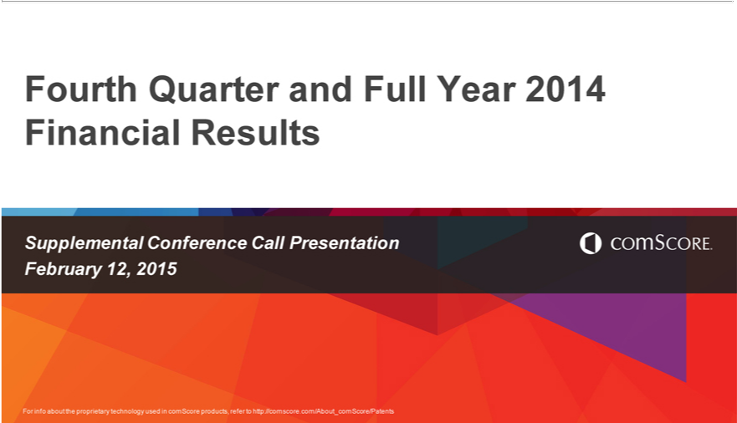

_{Financial}ourthQuarterResultsand Full Year 2014
Supplemental Conference Call Presentation February 12, 2015
For info about the proprietary technology used in comScore products, refer to http://comscore.com/About_comScore/Patents 1

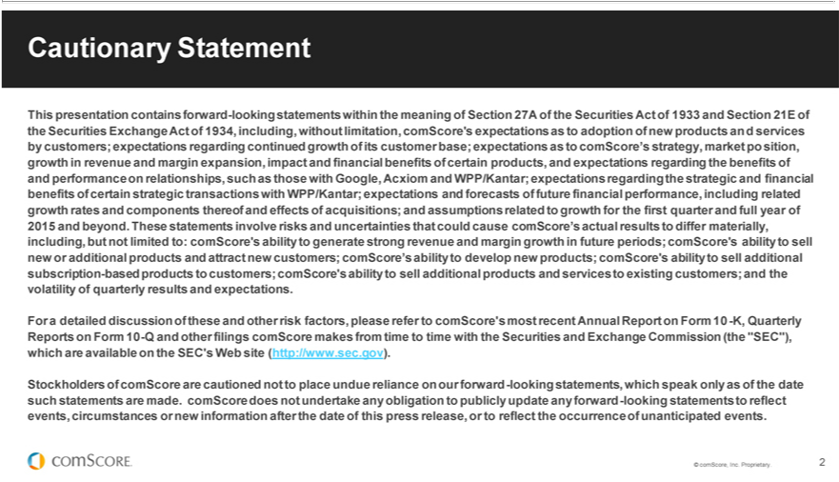

Cautionary Statement |  |  |  | without limitation,
This | contains forward-looking statements within the meaning of Section 27A of the Securities Act of 1933 and Section 21E of the Securities Exchange Act of 1934, |  |  | without limitation,
comScore’presentationexpectations as to adoption of new products an d services by customers; expectations regarding continued growth of its customer base; expectations as to comScore’s including,strategymarket po sition, growth in
revenue and margin expansion, impact and financial benefits of certain products, and expectations regarding the benefits of and performance on relationships, such as those with Google, Acxiom and WPP/Kantar;
expectations regarding the strategic and financial benefits of certain strategic transactions with WPP/Kantar; expectations and forecasts of future financial |  |  | including related growth rates and components
differ materially, including, but not limited to: comScore’s ability to generate strong revenue and margin growth in future periods; comScore’s ability to sellperformance,newadditional products and attract new customers;
thereof and effects of acquisitions; and assumptions related to growth for the first quarter and full year of 2015 and beyond. These statements involve risks |  |  | d uncertainties that could cause comScore’ actual results to
comScore’s ability to develop new products; comScore’s ability to sell additional subscription-based products to customers; comScore’s ability to sell additional products and services to existing customers; and the
 | of quarterly results and expectations.
volatilityFordetailed discussion of these and other risk factors, please refer to comScore’s most recent Annual Report on Form 10 -K, Quarterly Reports on Form 10-Q and other filings comScore makes from time to time with
the Securities and Exchange Commission (the “SEC”), which are |  | on the SEC’s Web site (http://www.sec.gov).
Stockholders of comScore are cautioned not to place undue relian availableonour |  | -looking statements, which speak only as of the date such statements are made. comScore does not undertake any obligation to
publicly update any forward-looking statements to reflect events, circumstancesforwardnew information after the date of this press release, or to reflect the occurrence of unanticipated events.
© comScore, Inc. Proprietary.
2

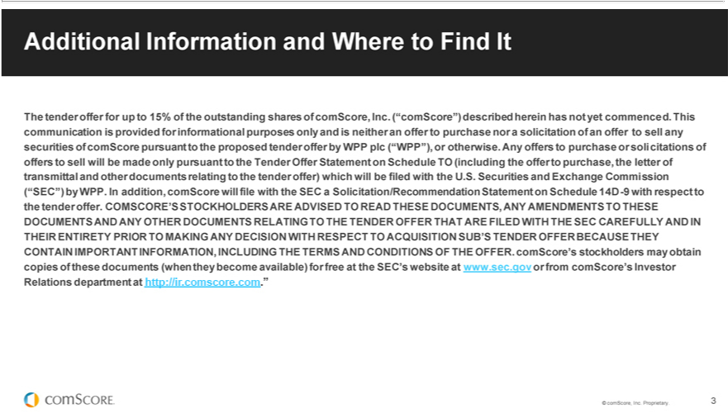

Additional | and Where to Find It |  | shares of comScore, Inc. (“comScore”) described herein has not yet commenced. This communication is provided for |  | purposes only and is neither an
The tender offer | up to 15% of the |  |  |  | purposes only and is neither an
offer to purchaseInformationnorsolicitation of outstandingoffertosell any securities of comScore pursuant to the proposed tender offer by WPP plc (“WPP”), or otherwise. Any offers to informationalpurchasesolicitations of offers to sell will be
made only pursuant to the Tender Offer Statement on Schedule TO (including the offer to purchase, the letter of transmittal and other documents relating to the tender offer) which will be filed with the U.S. Securities
and Exchange Commission
(“SEC”) by WPP. In addition, comScore will file with the SEC a Solicitation/Recommendation Statement on Schedule 14D-9 with respect to the tender offer. COMSCORE’S STOCKHOLDERS ARE ADVISED TO
READ THESE DOCUMENTS, ANY AMENDMENTS TO |  |  |  | OFFER THAT ARE FILED WITH THE SEC CAREFULLY AND IN
DOCUMENTS AND ANY |  | DOCUMENTS RELATINGTHESEO THE |  | OFFER THAT ARE FILED WITH THE SEC CAREFULLY AND IN
OTHER TENDER
THEIR ENTIRETY PRIOR MAKING ANY DECISION WITH RESPECT _{CONDITIONS}ACQUISITION SUB’S TENDER OFFER BECAUSE THEY
CONTAIN IMPORTANT INFORMATION, INCLUDING THE TERMS AND OF THE OFFER. comScore’s stockholders may obtain copies of these documents (when they become available) for free at the SEC’s website at www.sec.gov or from comScore’s Investor Relations department at http://ir.comscore.com.”
© comScore, Inc. Proprietary. 3

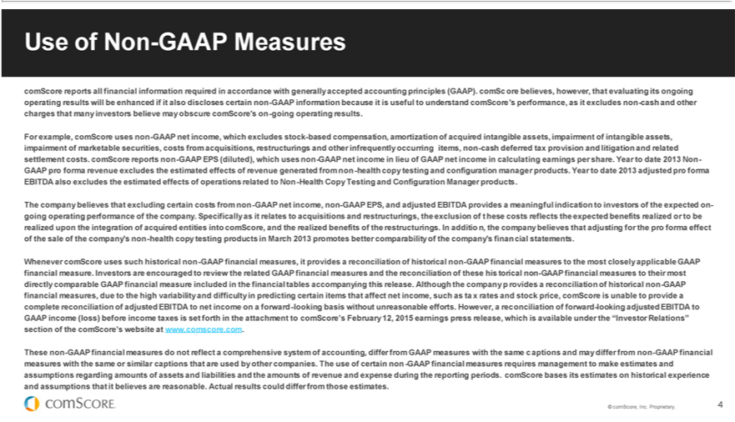

Use of Non-GAAP Measures
comScore reports all financial information required in accordance with generally accepted accounting principles (GAAP). comSc ore believes, however, hat evaluating its ongoing operating results will be enhanced if
it also discloses certain non-GAAP information because it is useful to understand comScore’s performance, as it excludes non-cash and other charges that many investors believe may obscure comScore’s on-going
operating results.
For example, comScore uses non-GAAP net income, which excludes stock-based compensation, amortization of acquired intangible assets, impairment of intangible assets, impairment of marketable securities, costs
from acquisitions, restructurings and other infrequently occurring items, non-cash deferred tax provision and litigation and related settlement costs. comScore reports non-GAAP EPS (diluted), which uses non-GAAP
net income in lieu of GAAP net income in calculating earnings per share. Year to date 2013 Non-GAAP pro forma revenue excludes the estimated effects of revenue generated from non -health copy testing and
configuration manager products. Year to date 2013 adjusted pro forma EBITDA also excludes the estimated effects of operations |  |  | to Non-Health Copy Testing and Configuration Manager products.
The company believes that excluding certain costs from non-GAAP net income, non-GAAP EPS, and adjusted EBITDA providesrelatedmeaningful indication to investors of the expected ongoing operating performance of
company. Specifically as it relates to acquisitions and restructurings, the exclusion of |  | hese costs reflects the expected benefits realized or to be realized upon the integration of acquired entities into comScore, and
the realized benefits of the | . In additio n, the company believes that adjusting for the pro forma effect of the sale of the company’s non-health copy testing products in March 2013 promotes better
comparability of the company’restructuringsfinancial statements.
Whenever comScore uses such historical non-GAAP financial measures, it provides a reconciliat on of historical non-GAAP financial measures to the most closely applicable GAAP financial measure. Investors are
encouraged to review the related GAAP financial measures and the reconciliation of these |  | torical non-GAAP financial measures to their most directly comparable GAAP financial measure included in the financial
tables accompanying this release. Although the company_{provide}rovides a reconciliation of historical non-GAAP financial measur_{income}s, due to the high variability and difficulty in predicting certain items that affect net income,
such as ta x rates and stock price, comScore is unable to a complete reconciliation of adjusted EBITDA to net on a forward-looking basis without unreasonable efforts. However, a reconciliation of forward-looking adjusted EBITDA to
GAAP income (loss) before income taxes is set forth in the attachment to comScore’s February 12, 2015 earnings press release, which is available under the “Investor Relations” section of the comScore’s website at www.comscore.com.
These non-GAAP financial measures do not reflect a comprehensive system of accounting, differ from GAAP measures with the same c aptions and may differ from non-GAAP financial measures with the same or similar captions that are used by other companies. The use of certain non -GAAP financial measures requires management to make estimates and assumptions regarding amounts of assets and liabilities and the amounts of revenue and expense during the reporting periods. comScore bases its estimates on historical experience and assumptions that it believes are reasonable. Actual results could differ from those estimates.

© comScore, Inc. Proprietary. 4

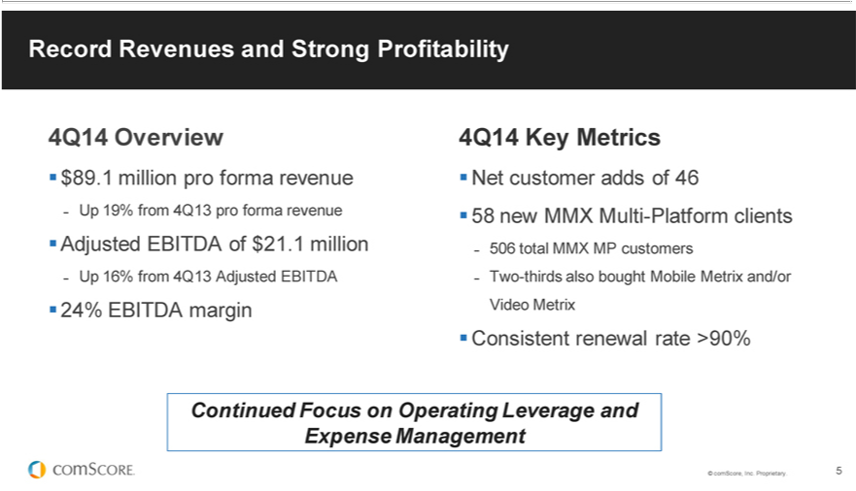

4Q14RecordOverviewRevenues and Strong Profitability
$89^{19%}.million pro forma revenue
UpAdjustedfromEBITDA4Q13ofpro$21.1formamillionrevenue
24%Up16%EBITDAfrom4Q13marginAdjusted EBITDA
4Q14 Key Metrics^{adds}
Net customer of 46
⁵⁰⁶
8 newtotalMMXMMXMultiMP-customersPlatformclients
_{Continued}Twosistent-thirds renewalalsoboughtrate Mobile>90% Metrix and/or Video Metrix
© comScore,FocusInc. onProprietary.Operating5Leverage and Expense Management

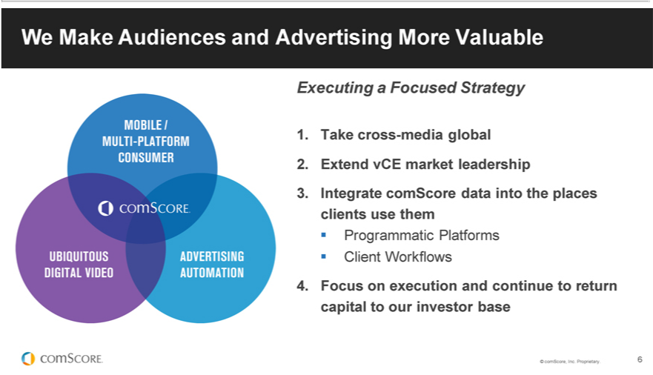

W_{Executing}Make AudiencesaFocused andStrategyAdvertising More Valuable
1 Take cross-media global
2. Extend vCE market leadership
Programmatic3IntegratecomScorePlatformsdata into the places clients use them
Client Workflows
©4. FocuscomScore,onexecutionInc.Proprietary.andcontinue6 to return capital to our investor base

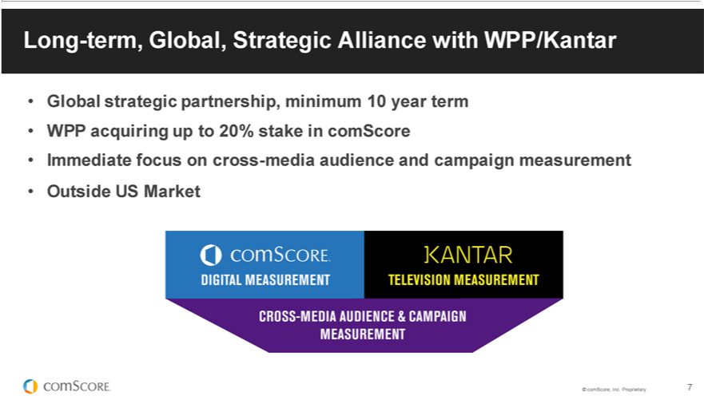

Long-term, Global, Strategic Alliance with WPP/Kantar
WPPGlobalacquiringstrategicuppartnership,to20%stake_{minimum}comScore10year term
OutsideImmediateUSfocusMarketon cross-media audience and campaign measurement
© comScore, Inc. Proprietary. 7

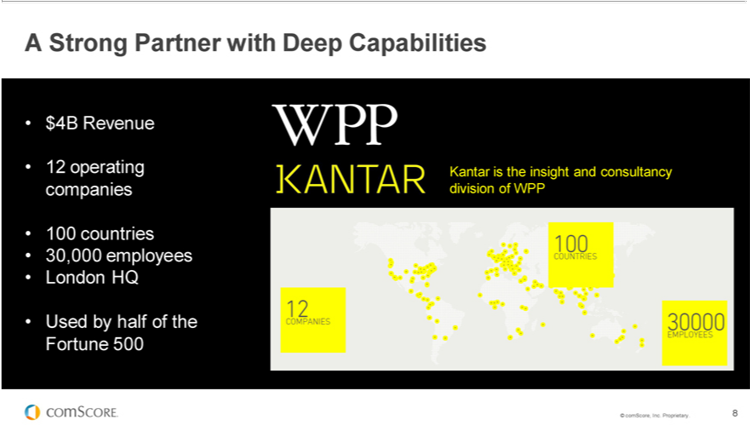

$A4BStrongRevenuePartner with Deep Capabilities
¹⁰⁰2operating companies
Usedcountriesbyhalfof30,000theFortuneemployees500 London HQ
©KantarcomScore,isthe insightInc.Proprietary.andconsultancy8 division of WPP

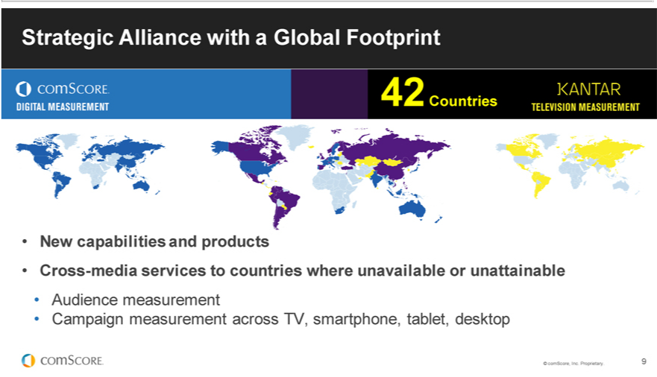

Strategic Alliance with a Global Footprint
42 Countries
New capabilities and products
Cross_{Audience}-mdiameasurementservicesto countries where unavailable or unattainable
©CampaigncomScore,measurementInc.Proprietary.across9TV, smartphone, tablet, desktop

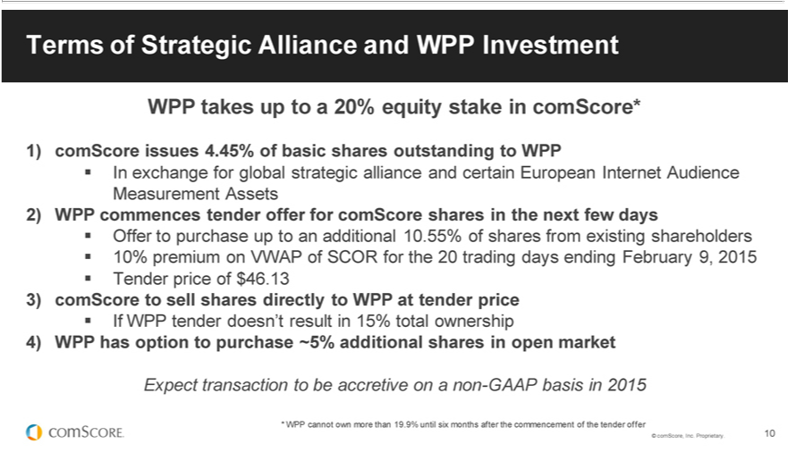

Terms of Strategic Alliance and WPP Investment
WPP takes up to 20% equity stake in comScore*
In1) exchangecomScore forissuesglobal4.45%strategicofbasicalliancesharesandoutstandingcertainEuropeantoWPP Internet Audience
Measurement Assets
Offer2)WPPto commencespurchaseup tendertoanadditionalofferforcomScore10.55%ofsharessharesinfromthe nextexistingfew shareholdersdays
10% premium on VWAP of SCOR for the 20 trading days ending February 9, 2015
3)TendercomScoreprice ofto $sell46.13shares directly to WPP at tender price
If WPP tender doesn’t result in 15% total ownership
Expect4)WPPtransactionhasoption toto bepurchaseaccretive~5%onadditionalnon-GAAPsharesbasisin inopen2015market
©* comScore,WPP Inc.cannotProprietary.ownmore10than 19.9% until six months after the commencement of the tender offer

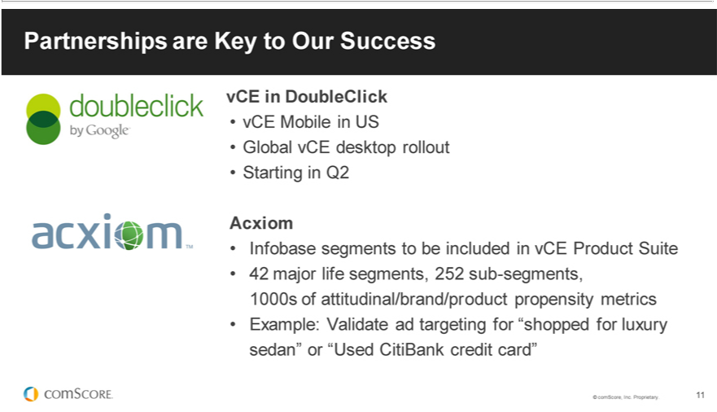

Partnerships are Key to Our Success
in DoubleClick
vCE Mobile in US
Global vCE desktop rollout
Starting in Q2
Acxiom | to be included in vCE Product Suite
Infobase segm | to be included in vCE Product Suite
42 major life segments, 252 sub-segments,
1000s of attitudinal/brand/product propensity metrics
Example: Validate_{Proprietary}adgeting for “shopped for luxury sedan” or “Used CitiBank credit card”
© comScore, Inc. . 11

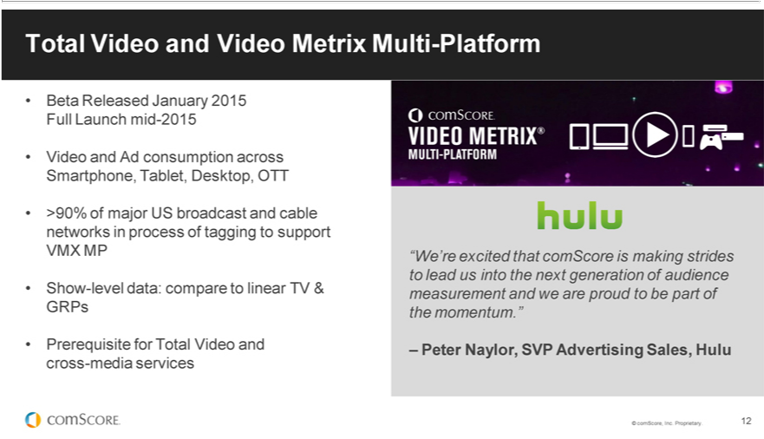

BetaTotal ReleasedVideoandJanuaryVideo Metrix2015FullMultiLaunch-Platformmid-2015
Video and Ad consumption across Smartphone, Tablet, Desktop, OTT
Show>90%-levelofmajordata:UScomparebroadcastto linearandcableTV &networksGRPs in process of tagging to support VMX MP
Prerequisite for Total Video and cross-media services
“W_{Peter}’re excited that comScore_{Advertising} making strides to lead us into the next generation of audience measurement and we are proud to be part of the momentum.”
©– comScore,Naylor,Inc.SVPProprietary. 12 Sales, Hulu

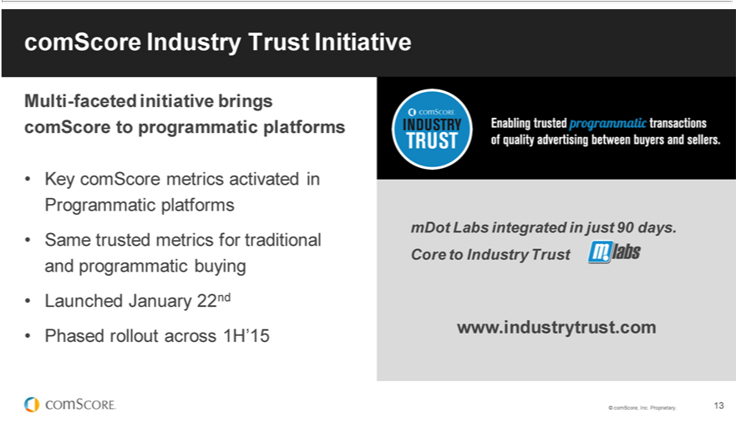

comScore Industry Trust Initiative
MultiKeycomScore-facetedinitiativemetrics activatedbringscomScoreinProgrammatictoprogrammaticplatformsplatforms
LaunchedSametrustedJanuarymetrics22ndfor traditional and programmatic buying
Phased rollout across 1H’15
www.industrytrust.commDotLabsintegratedin just 90 days. Core to Industry Trust
© comScore, Inc. Proprietary. 13

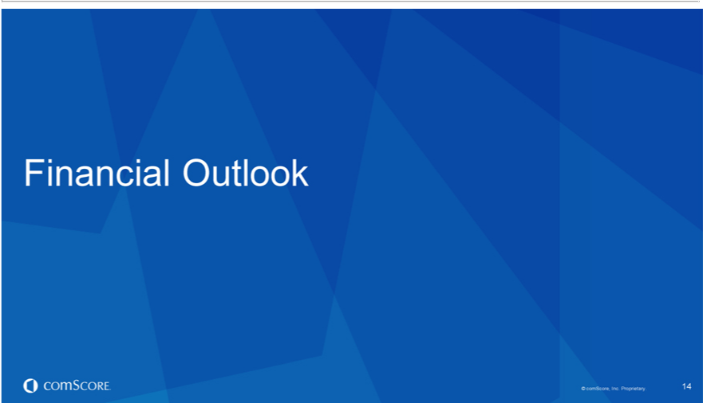

Financial Outlook
© comScore, Inc. Proprietary. 14

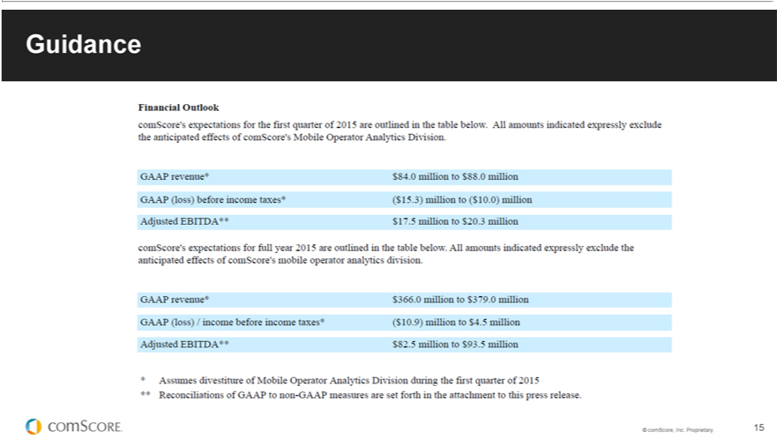

Guidance
© comScore, Inc. Proprietary. 15

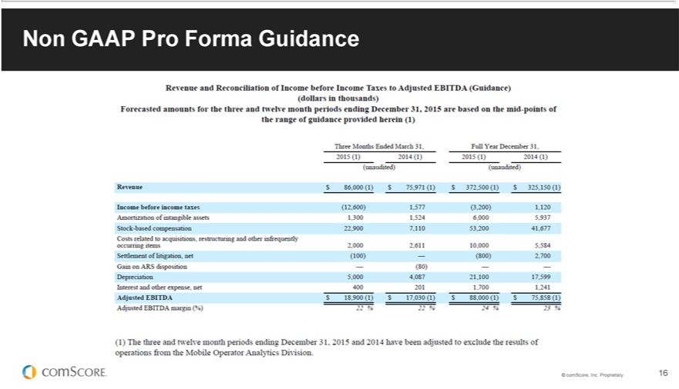

©NoncomScore,GAAPProInc.FormaProprietary.Guidance16

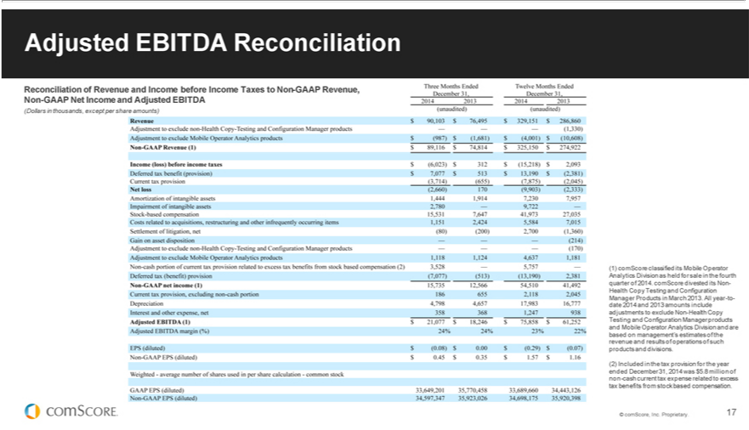

Adjusted EBITDA Reconciliation
Reconciliation of Revenue and Income before Income Taxes to Non-GAAP Revenue, Non-GAAP Net Income and Adjusted EBITDA
⁽¹⁾
Dollars comScoreinthousands,classifiedexcept itsperMobileshare amounts)Operator
Analytics Division as held for_{Health}sin the fourth quarter of 2014. comScore divested its Non-Health Copy Testing and Configuration Manager Products in March 2013. All year-to-date 2014 and 2013 amounts include
adjustments to exclude Non- Copy
Testing and Configuration Manager products and Mobile Operator Analytics Division and are based on management’^{expense}estimates of the revenue and results of operations of such products and divisions.
(2) Included in the tax provision for the year ended December 31, 2014 was $5.8 million of non-cash current tax related to excess tax benefits from stock based compensation. © comScore, Inc. Proprietary. 17

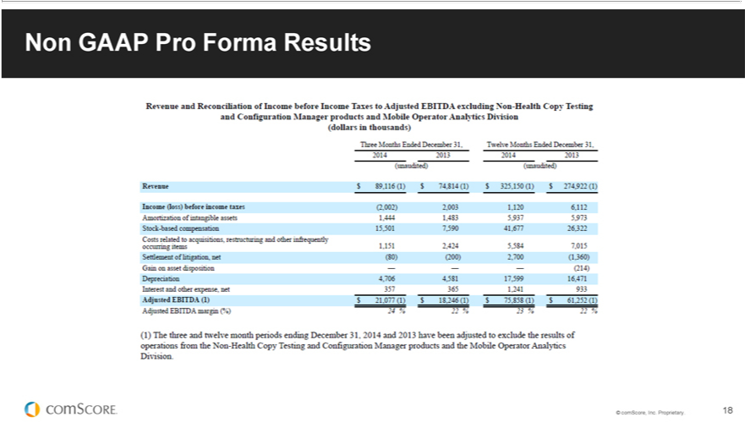

©NoncomScore,GAAPProInc.FormaProprietary.Results18



Thank you.
www.comscore.com @comScore www.linkedin.com/company/comscore www.facebook.com/comscoreinc
For info about the proprietary technology used in comScore products, refer to http://comscore.com/About_comScore/Patents

Q4 2014 COMSCORE INC EARNINGS CALL TRANSCRIPT

FEBRUARY 12, 2015

TIME 8:30 AM ET

Operator

Good day ladies and gentlemen and welcome to the comScore fourth-quarter and full-year 2014 financial results conference call. My name is Adrian and I will be your operator for today.

(Operator Instructions)

As a reminder this call is being recorded for replay purposes. I would now like to turn the call over to him Mel Wesley Chief Financial Officer. Please proceed.

Mel Wesley - comScore Inc - Chief Financial Officer

Thank you, good morning and welcome to comScore’s earnings call for the fourth quarter of 2014. I’m Mel Wesley comScore’s Chief Financial Officer and with me today is Serge Matta President and Chief Executive Officer. Before we begin please allow me to read the following disclaimer regarding our use of forward-looking information and non-GAAP financial measures.

During the course of today’s call as well as during any question-and-answer periods that may follow, representatives of the company may make forward-looking statements within the meaning of Securities Act of 1933 and the Securities Exchange Act of 1934 regarding future events or performance of the company that involve risks and uncertainties. Including without limitation expectations as to opportunities for comScore including customers, markets, and partnerships, expectations as to the strength of comScore’s business, including the growth and composition of comScore’s customer base and renewal rates.

Expectations regarding comScore’s products including regarding new releases and features their quality relative to competitors and the potential benefits of a particular products. Expectations regarding the strategic and economic benefits of certain strategic relationships such as; those with Google, Yahoo, and WPP Kantar, expectations as to the financial effects of comScore’s expected divestiture of certain business lines and related impairment losses, assumptions regarding tax rates and not operating loss carry forwards, and forecasts of future financial performance for the first quarter and full-year 2015 including related growth rates, exchange rates, and assumptions.

Such statements are only predictions based on management’s current expectations. Actual events or results could differ materially from those predictions due to a number of risks and uncertainties. Including those identified in the documents comScore files from time to time with the Securities and Exchange Commission.

Those documents specifically include but are not limited to comScore’s form 8-K filed earlier today relating to this call, and comScore’s form 10K for the period ending December 31, 2013, and comScore’s most recent quarterly report on form 10-Q. We caution you not to place undue reliance on any forward-looking statements included in these presentations. Which speak only as of today. We do not undertake any obligation to publicly update any forward-looking statements to reflect new information after today’s call or to reflect the occurrence of unanticipated events.

In addition we may also reference certain non-GAAP financial measures in the course of our presentation. You will find in our press release in our investor relations website, a reconciliation of non-GAAP financial measures discussed during today’s call to the most directly comparable GAAP financial measures. The link to our investor relations website is IR.ComScore.com and our results are posted under press releases.

We have a presentation posted on our IR website under events and presentations that corresponds to our comments today and will be helpful as you follow along.

With that I will now turn the call over to Serge.

Serge Matta - comScore Inc - President & CEO

Tank you Mel. Welcome to today’s call everyone. We have a lot to cover, so I will begin with a brief overview of the quarter and then provide details regarding the strategic alliance we announced this morning with WPP’s Kantar group. Then I’ll report on some key operational highlights from what has been a very quick start to the year. I’ll then turn it over to Mel to provide a detailed review of our financial performance before we take your questions. Similar to previous quarters we have a slide deck to review.

Let’s begin with slide 4. ComScore delivered another quarter of record revenues and strong profitability. This reflects continued positive momentum across our business and the strength of our partnerships which continue to grow in number and impact. On a pro forma basis fourth quarter 2014 revenue was $89.1 million up 19% over last year. Adjusted EBITDA was $21.1 million a 16% year-over-year increase and a 24% adjusted EBITDA margin. Reflecting the significant operating leverage we have in the business and our focus on managing expenses.

1

During the fourth quarter, excuse me, we added 46 net new customers for our overall business for a total of 2545 customers at the close of 2014. We added 58 new customers to our Media Metrix Multi-Platform service for a total of 506 MMX MP customers at years end. Two thirds of these multi-platform customers also bought Mobile Metrix and/or Video Metrix during the same quarter, continuing a trend of highlighted before.

We see this as a validation that customers place significant value on our entire suite of service offerings and continue to embrace our market-leading products that measure the multi-platform world. Our contract rate with existing customers again remained above 90% on a constant dollar basis.

Moving to slide 5. For the past year we’ve been opening these calls with this Venn diagram which expresses our thesis about three mega-trends driving the digital media and advertising ecosystem.

First the rapid emergence of the multi-platform consumer who connects with media across multiple devices and platforms. Second the ubiquity of video and television that’s reaching consumers through increasingly digital channel. And lastly the rise of advertising automation which is changing how advertising is bought and sold.

As we pursue our mission of making audiences and advertising more valuable, our strategy has been focused on leveraging the data assets, partnerships, and client relationships which give us a strong competitive position at the intersection of these trends. Throughout 2014 we delivered on the key priorities that supported this strategy. In 2015 our focus continues to sharpen as we concentrate on first expanding our cross media offerings globally, second extending vCE market leadership, third integrating comScore data into the places clients use them with a focus on integrating our data into programmatic platforms and client work flows, and forth focusing on execution and continue to return capital to our investor base.

As we refined our strategy and build momentum over the past year we’ve looked for ways to amplify the impact of our unique capabilities and dramatically expand out addressable market and growth opportunities. That’s the rationale behind the strategic long-term global alliance we have announced earlier this morning with WPP’s Kantar group.

Turning to slide 6. In 1999 the founding thesis of comScore was the digital media would transform the interactions between people, media, and brands. In 2015 this is obvious and the digital media revolution has profoundly changed the way that advertising works and audiences are valued. Over the past 12 months we’ve seen an acceleration in the transformation of the video and television audience as consumers access TV and video across multiple devices, shift their viewing patterns to fit their own schedule, and increasingly do so in ways that challenge the traditional broadcast and cable television model.

Enormous opportunities are emerging for media companies and marketers who can crack the cross media code. This global opportunity would be undermined by inadequate measurements that fails to account for all video viewing with sufficient accuracy. A concern that has been frequently voiced by industry players around the world.

The solution to this complex problem requires technological innovation, deep measurement expertise, and individual country knowledge. We believe that the alliance between comScore and Kantar delivers all of this and more. By combining Kantar’s global experience in TV and media measurement with comScore’s existing and new measurement technologies we will deliver a truly global solution that addresses the requirements of the entire media industry. There multiple aspects to our long-term global strategic alliance that are important to explain.

Moving on to slide 7. Let me first talk a bit about Kantar and explain why we’re so excited to have forged this alliance. As the data investment management arm of WPP, Kantar’s one of the world’s largest insight information and consultancy groups. With annual revenues of around $4 billion the Kantar group of companies employs 30,000 people in 100 countries across the whole spectrum of research and consultancy disciplines.

Kantar has built a tremendous set of assets that are complementary to those that we’ve built at comScore and offers its clients insight at every point of the consumer cycle. Kantar services are employed by over half of the Fortune 500.

As we’ve been meeting with Kantar CEO Eric Salama and the Kantar team over the past several months it’s become clear to us that their combination of deep media and TV measurement expertise and global footprint is unmatched. We both quickly realized that the opportunity for our partnership is massive as we provide new capabilities to all of our existing and new clients.

Moving to slide 8. Our immediate focus is on combining our assets and expertise to jointly deliver cross media audience and campaign measurement in markets outside the United States, leveraging a consistent methodology around the world. Kantar is the leader in TV measurement outside the United States and today delivers its television audience measurement services also known as TAM in 41 countries.

Today comScore delivers digital audience measurement services in 44 countries. Working together we will be able to combine digital media and video with television data to deliver new cross media capabilities and products across the globe. This alliance will help the media industry in a variety of ways. Helping increase accuracy and more comprehensive measurement; including bringing services to market where they are unavailable today and in many cases would be unattainable without our partnership.

2

Together we can provide the global medium marketplace with accurate reliable and innovative Measurement Solutions that the industry is calling for. Our focus here is not just on audience measurement, but also on advertising campaign measurement. At comScore we’ve been developing cross media vCE to provide campaign level insights across TV and digital media.

The ability to measure individual campaign performance across TVs, smart phones, tablets, and desktops provides new and powerful insights to marketers. Our alliance with Kantar would catalyze and accelerate the base of our global rollout. Together we’re embarking in a multi-your journey to deliver transformational services to our dynamic global marketplace.

Turning to slide 9. To reinforce their commitment to the success of this partnership WPP is taking an equity stake in comScore. I know you’re eager to understand this investment part to let me explain the financial transaction.

Our agreement runs for a minimum of 10 years and is expected to be accretive on a non-GAAP basis in 2015 to comScore. As the foundation to our strategic cross media partnership WPP expects to acquire an equity stake just shy of 20% in comScore through a combination of direct issuances and third-party transactions.

There are four parts to this transaction. First we will be issuing new shares equivalent to 4.45% of basic shares outstanding in exchange for entering into our global strategic alliance and acquiring certain European Internet audience measurement assets. Second WPP will commence a tender offer for comScore shares in the next few days for approximately 15% of shares from existing shareholders. The tender offer represents a 10% premium on the volume weighted average price of comScore stock for the 20 trading days ending February 9, 2015 at a price of $46.13. Third in the event the tender offer doesn’t reach at least 10.55% of shares outstanding for a total of 15% comScore will directly sell additional shares at the previously mentioned tender price to help WPP reach 15% ownership. Lastly WPP may purchase an additional 5% of comScore shares outstanding to attain a total ownership stake in comScore of between 15% to 20%.

The entire transaction is subject to customary regulatory approvals including HSR and expected to be completed later in the year. So what is this all mean for comScore? This strategic alliance will be transformative to comScore’s business and to the entire industry. Together with WPP and Kantar we’ve worked for over a year to make sure our companies goals are aligned, and to ensure that this partnership succeeds, and that were able to fulfill on its promise; which is to bring cross-platform solutions to markets where these types of solutions have not been available or even attainable.

That success depends on comScore maintaining its stature as a trusted source of independent third-party metrics. The value we bring to our clients and the broader market requires trust in our position as a neutral objective and independent third-party. While WPP will be taking a substantial equity stake in our company they fully understand the importance of comScore’s neutrality and independence. Accordingly WPP will not have a board seat either as a member or observer. We recognize that it is strongly in all of our interest to ensure that comScore continues to deliver trusted and independent data and services to all our media agency, advertiser clients, and the industry at large.

Finally as we’ve met with Kantar over the past year it’s become clear to both of us that there are also powerful opportunities that extend beyond our immediate focus on cross media audience and advertising measurement outside the US, but we’ve covered enough and we’ll leave that discussion for another day. Were obviously excited to announce our alliance with Kantar this morning and I’m sure you’ll all have questions but there are several other items that I want to report on.

Turning to slide 12. 2014 saw a strong emphasis on partnerships at comScore as we work to bring our data to the places clients use them and expand and enrich our data sets which help make our products so valuable to clients. A year ago we announced partnerships with both Google and Yahoo to integrate vCE into their app server work flows. Our beta with Google went live in Q4 of last year and we are on schedule to exit the beta period within double-click by the end of Q1 of this year.

I’m pleased to announce this morning we’re extending vCE in double-click along to additional key dimensions. First in the US vCE and double-click will be available for mobile advertising. This is an extremely important step as we all know how critical it has become to measure mobile campaigns in a scalable platform. Second vCE and double-click for desktop advertising will become available globally and we plan to jointly rollout several countries in 2015. These additional services will begin rolling by the end of Q2.

We’ve been working with Google for the past few months to make this happen and we’re both excited that this additional layer strengthens our partnership even further. On our Q3 earnings call I announced the partnership we signed with Pandora to bring their demographic data into vCE mobile. As a reminder Pandora — as a reminder excuse me Pandora has over 200 million registered users in the US with 81.5 million of them active in a given month. I’m pleased to announce that as of January we are now receiving this data stream and we will be soon activating it within vCE mobile.

3

Rich in granule demographic data is a key building block for vCE, but we want to go beyond age and gender which today are the predominant demographic variables used in digital advertising. We intend to ultimately incorporate behavioral, lifestyle, and off-line segment data into our measurements. That’s why in Q4 we signed an agreement with Acxiom Corporation deepening our existing partnership.

Our agreement will bring Acxiom’s InfoBase consumer segmentation into the comScore vCE product suite. This data allows us for example, to extend the audience validation we offer in vCE to advertise is targeting likely purchases of luxury sedans or consumers who shop with a particular credit card in the past 12 months.

Acxiom InfoBase provides data on 42 major life segments, 252 sub segments, and thousands of at general brand and product propensity ratings. It’s inclusion in our vCE product suite will be a significant enhancement to our capabilities.

Moving on to slide 13. We opened 2015 with two major product announcements that directly advance our corporate strategy. The release of Video Metrix Multi-Platform and the launch of comScore industry trust.

In 2014 we announced Total Video our approach to providing cross media measurement that includes digital, video, and linear TV. We’ve been working hard on building and assembling the many complex pieces required to deliver syndicated cross media services and have been delivering private data to clients such as ESPN, NBC, ABC, Sim among others. Now a prerequisite for our total video solutions is Video Metrix Multi-Platform. Which provides unduplicated audience measurement for digital video consumption across desktop, Smartphone, tablets, and over-the-top video.

We announced the beta availability of Video Metrix Multi-Platform also known as VMX MP in mid-January. The industry has quickly rallied behind us based on this announcement and we’re in the process of tagging with 79 video publishers in the US including more than 90% of major broadcast and cable networks.

Client subscriptions to Video Metrix continue to grow and VMX MP is obviously important in its own right, but it should also be seen as a key building block for our work in delivering total video measurement and the global work will be doing jointly with WPP and Kantar. Video Metrix MP launched in data in the US and will come out of beta midyear. We’ll deliver Video Metrix Multi-Platform and additional market later this year.

Moving to slide 14 in late January we launched comScore Industry Trust an important multi part initiative that will be fully rolled out over the course of 2015. As the name implies industry trust tackles head-on a fundamental problem in today’s advertising ecosystem. Which is the increasing lack of trust between ad buyers and sellers resulting from fraud and non-human traffic that has become a fixture of programmatic advertising.

With industry trust where enabling trusted transactions by activating key comScore metrics non-human traffic data, Media Metrix rankings, vCE view ability metrics, and demographics directly in programmatic trading platforms. The first integrations for Media Map, Turn, The Trade Desk, Rubicon Project, and Eyereturn will be completed soon and we expect many more to follow.

The technology and data behind industries trust is based in part on the work of MdotLabs which we acquired six months ago. Our team completed the Mdot integration with comScore data and systems in just 90 days and it’s now a core component of our industry trust initiative. Through industry trust were giving media buyers the ability for the first time to conduct traditional and programmatic buys based on the same set of trusted metrics.

Industry trust also supports the needs of ad sellers providing a mechanism for premium publishers to distinguish themselves on programmatic platforms through the quality of their inventory certified by neutral third-party comScore. We’re putting our data in the places clients need to use them. We’ll be talking at greater length about this important initiative as the year goes on but I’d encourage you to find out more details now by going to www.industrytrust.com.

With Media Metrix MP, Video Metrix MP, vCE, and comScore industry trust we’re bringing solutions to market that make audiences and advertising more valuable. Our new strategic alliance with Kantar and our growing relationship with Google and other partners are bringing our solutions to market in new ways globally and at massive scale.

We’re embarking on this next phase in technology and measurement innovation at exactly the right time and I look forward to updating you over the next several quarters on our progress. Now I’ll turn it over to Mel for a review of our financial results.

Mel Wesley - comScore Inc - Chief Financial Officer

Thank you Serge. I will now provide more details regarding our fourth-quarter results. Revenue in the quarter was $89.1 million on a pro forma basis up 19% versus the same quarter last year. We are pleased with our revenue growth despite foreign currency exchange rate headwinds. If exchange rates against the US dollar remain constant from the same quarter last year our Q4 pro forma revenue would have been $1.5 million or 2% higher.

4

Subscription revenue in the quarter was $81 million on a pro forma basis up 21% versus the same quarter last year. Subscription and project revenue represented 91% and 9% of total revenue respectively. The ongoing success in customer adoption of vCE continues to drive our subscription revenue mix higher.

Revenue from existing customers was $82.4 million on a pro forma basis. Up 22% year-over-year and representing 92% of total revenue. During the quarter we also added 46 net new customers bringing our total customer count to 2545 on a pro forma basis.

Our international revenue on a pro forma basis also continued to grow up 16% year-over-year and representing 28% of total revenue. As Serge mentioned in December we signed an arrangement with an existing customer to acquire key data assets for future use in our products. And return we provided them with historical behavioral data for use in predictive advertising analytics. The transaction resulted in $4.5 million of Q4 revenue and $6.3 million of Q4 R&D expense we believe this investment will significantly enhance future products in 2015 and beyond.

Turning to margin and expenses on a GAAP basis our gross margin was 71% increasing 3% over the same quarter last year. The higher gross margin trends this year are primarily attributable to operating model leverage from increased scale and tight expense controls.

Selling and marketing expense decreased to $24.7 million down $1 million from the same quarter last year. The decrease was largely the result of lower travel and advertising costs.

R&D expenses increased to $21.2 million for the fourth quarter up from $10.6 million from the same quarter last year. The increase is primarily the result of data acquisition costs including the arrangement previously discussed that added $6.3 million of R&D expense this quarter.

G&A expenses increased to $20 million for the fourth quarter up from $13.7 million from the same quarter last year. The increase is primarily due to stock-based compensation expense driven by the market based grant issued in November. I will provide additional grant details during my discussion of stock compensation expense.

GAAP pretax loss for the quarter was $6 million compared to GAAP pretax income of $312,000 in the same quarter last year. The decrease was primarily the result of a $2.8 million impairment charge during the quarter related to our mobile operator division and higher stock compensation expense. The impairment charge was necessary given a classification of that division as held for sale at December 31.

In addition we were unable to complete the sale of the division under the terms of the LOI that was signed in October 2014. Our intent to divest the division has not changed.

The higher stock compensation expense resulted from a market-based stock grant issued in November that contributed $7.9 million of incremental stock-based compensation expense during Q4. During the quarter stock compensation expense was $15.5 million compared to $7.7 million for the same quarter last year. The increase relates to the market based grant that was approved by our compensation committee and issued in November. Vesting of which is conditional on significant appreciation and comScore’s share price.

This grant outlined in an 8-K filed in November is designed to align management and shareholder interests during its three-year term by motivating existing and newly appointed executives to drive shareholder value significantly higher. In accordance with applicable accounting guidance we will record the grant expense regardless of whether the share price conditions are achieved and the shares vest. Given the structure of the grant 80% of the grant expense or $21 million will be recorded by the end of Q1 of 15 and 100% of the grant expense or $26.1 million will be recorded by the end of 2015.

This is only the second market based grant approved during the company’s history and is intended to drive tangible returns to our shareholders. The expense associated with this grant is included in our guidance.

We generated a tax benefit during the quarter of $3.4 million compared to a tax expense of $142,000 for the same quarter last year. The tax benefit this quarter was primarily the result of a change in the status of our mobile operator division and the related impairment together with the associated tax treatment. We expect our cash taxes to remain low in the near term as we hold net operating loss carry forwards in the US and certain foreign jurisdictions.

During the quarter GAAP net loss was $2.7 million or $0.08 per basic and diluted share based on a basic and diluted share count of 33.6 million shares. Non-GAAP net income for the quarter was $15.7 million or $0.45 per diluted share excluding stock-based compensation the impairment charge related to our mobile operator division, amortization of intangibles, acquisition related expenses, and other nonrecurring items. Our non-GAAP EPS calculation is based on a fully diluted share count of 34.6 million shares.

5

Fourth-quarter adjusted EBITDA was $21.1 million or a 16% increase over the prior-year representing an adjusted EBITDA margin of 24%. We are pleased by the continued margin expansion we’ve generated in our core business and we expect these gains to provide us with incremental investment dollars to accelerate key projects we believe will contribute significant ROI.

Looking at our balance sheet we ended the quarter with cash and cash equivalents of $43 million an increase of $3 million sequentially and a decrease of $25 million from the same quarter last year. The decrease from last year primarily reflects $37 million of share repurchases in connection with our stock repurchase program partially offset by cash flow from operations.

Cash flow from operations for the fourth quarter of 2014 was $7.5 million and capital expenditures for the quarter were $1.1 million resulting in free cash flow of $6.4 million. Free cash flow for the same quarter last year was $4.7 million. The increase in free cash flow was primarily the result of strong accounts receivable collections activity.

Slide 15 details our guidance. It is important to note that the following guidance ranges exclude the financial impact of the mobile operator division as the division is currently classified as held for sale. For the first quarter of 2015 we anticipate revenue on a pro forma basis in the range of $84 million to $88 million.

We anticipate GAAP loss before income taxes on a pro forma basis in the range of $15.3 million to $10 million. The guidance range is driven by $13.1 million of expense associated with the previously discussed market-based stock grant.

We anticipate adjusted EBITDA to be in the range of $17.5 million to $20.3 million which represents an adjusted EBITDA margin range of approximately 21% to 23% or 22% at the midpoint of our revenue and adjusted EBITDA guidance ranges. For the full quarter of 2000 — sorry for the full year of 2015 we anticipate revenue on a pro forma basis in the range of $366 million to $379 million.

We anticipate GAAP income before income taxes on a pro forma basis in the range of a $10.9 million loss to income of $4.5 million. The guidance range is driven by $18.2 million of expense associated with the previously discussed market-based stock grant.

We anticipate adjusted EBITDA to be in the range of $82.5 million to $93.5 million which represents an adjusted EBITDA margin range of approximately 23% to 25% or 24% at the midpoint of our revenue and adjusted EBITDA guidance ranges. We will now open the line for questions.

QUESTION AND ANSWER

Operator

‘s back ladies and gentlemen

(Operator Instructions)

Youssef Squali of Cantor Fitzgerald.

NEW SPEAKER

It looks like you guys have been pretty busy this quarter so congrats. A couple questions. First maybe you can just dig a little deeper into the areas of strength in the quarter by business product vCE tax and MPX et cetera. And vCE in particular maybe you can comment on the contribution of Yahoo and Google in the quarter and the have a follow-up.

NEW SPEAKER

Take the second part of your question first. And then I’ll turn it over to Serge. For the revenue generation by the Google Yahoo partnerships during the quarter it was in the low seven-figure range.

6

NEW SPEAKER

And is Mel’s adjusted hey Youssef. As far as the other been a unit everybody for doing well vCE specifically has beaten all of our internal expectations obviously the partnerships that we announced all last year have helped to do that but we are on track for vCE were actually beating all of our — beating all of our estimates on vCE. And we are extremely bullish on that product line. In terms of the others MMX MP is the one I really want to highlight. That product I remember just to tell everybody remind everybody what that is it’s the D duplicated audience measurement service for mobile and desktop and that product we’ve mostly rolled out in the US and a few other countries. That product there’s no other way to say it that is on fire. Everybody is buying at we have already Media Metrix MP customers at years in. Most of those are in the last. We started launching or rolling those out in additional countries. But and will — will do a phased rollout in several new countries this year Brazil Spain and others. The key gaining factor for that product is mobile and we need mobile measurement panels in each of those countries so before we can do that and that’s always been the gaining factor that we’ve had but were fortunate enough to be doing extremely well in the US and rolling it out in additional — in additional countries.

NEW SPEAKER

And then on the partnerships — partnership you announced this morning just a quick clarification on Kantar maybe you can comment on it not being — it’s only outside the US. So is that just a function of the date of that Kantar has an maybe not being able to supply you with US data or is there anything else? And then on the WPP ownership I’m not sure how WPP owning almost 20% of the company will not hamper your ability to deal with other agencies. Have you had any conversations with other agencies and feel confident that that will not be the case considering your no longer Switzerland.

NEW SPEAKER

There’s an easy way — there’s an easy way to differentiate before Kantar and Kantar by the way it’s not that hard. It’s not that hard but realistically Youssef onset outside of the US — Kantar does not have TV audience measurements services in the US. They did have some and they sold it off in a transaction. They did with a company called Rentrak last year. So this agreement focuses on 100% on non-US markets and again it’s non-US markets for not only just the cross media audience measurement piece but it also focuses on cross media campaign measurement piece. So — they have Kantar as I mentioned earlier — Kantar has over 42 countries where they are — where they have the television audience measurement service we measure 44 countries digitally. So in a lot of countries what happens is there something called the, which is the joint industry committee and what the, does is a point of research provider to measure TV and the research provider to measure the Internet. For example in the UK the organization is called Barb which is — and they have anointed Kantar as its provider. You, is the Internet audience measurement of association and they have anointed comScore — comScore to measure. So there’s a lot of — new opportunities where we can do this not just in the UK but obviously in a lot more countries where we have between the two companies. As far as your second question and the objectivity. Obviously our biggest concern here right so when we been working with WPP and Kantar and WPP has recognized this from day one that they want to make sure that even with an investment in comScore that we remain completely independent and actually disagree we are still a Switzerland here. This is — this is — and that’s why we insisted that WPP does not take a board seat or a board observer in our — in comScore. That’s extremely important. Now as far as the agency and the objectivity and all of that stuff the end of the day all of our agency clients have been asking for cross media measurements across — globally. This is an and industry initiative that they’ve been asking for and we came together with Kantar media and the Kantar group and us to bring this to our agency clients and all of our other clients not just the agency. So it’s an industry initiative that they’ve been asking for and this is one way to solve for it.

NEW SPEAKER

Thanks Serge. Thanks Mel.

NEW SPEAKER

Robert Peck of SunTrust.

NEW SPEAKER

Congratulations on the WPP deal. I wanted to start their because first of all how should we think about list for comScore not only in 2015 based on the deal but 2016 going forward and then as part of the guidance for 2016 can you tell us what your baking in? And have a quick follow-up on that.

7

NEW SPEAKER

Hey Bob. It’s now. We definitely have revenue baked into 2015. We’re not disclosing what that is. We feel like we’ve been conservative obviously the strategic alliance portion will take some time to ramp. But that is definitely contemplated in our 2015 guidance. ‘s back and then Mel can you walk us through how are the economics? On the new products are capabilities that you formed gather how does economics of those products without between the two?

NEW SPEAKER

So sure we’re going to be working with them to work through a revenue sharing type arrangement. Those have not been completely hammered out yet but that is in process.

NEW SPEAKER

This is Serge. These things with the cross media measurement service these things takes time. This is a — feel this capability did not exist before was not attainable in a lot of different areas. Now we have that capability jointly with Kantar we’re going to go and put the two products together and then we’re going to go jointly bid to the individual in each of the individual countries. It’s a process. It takes time but prior to this announcement comScore did not have a true robust cross media measurement service in — in countries outside of the United States and we feel now with this combination we are — were very well-positioned.

NEW SPEAKER

Switching gears really quickly here. Mel could you tell us what you baked in for 2015 on the vCE with double-click and then also along with the total video for 2015?

NEW SPEAKER

So we definitely have obviously revenues big into our plan for that. It’s included in the guidance. We’re not breaking out those at a product level. But those are definitely baked into the plan. ‘s back now to be fair we have baked in in these numbers what we have baked them very conservatively and mostly because Google is still in beta and we expect to get — out of beta at the end of Q1. So we still — it’s way too early to fully take everything into — into the numbers just because we need more time. It’s still in beta there’s also seasonality issues that we have to consider. So but again like Mel said we have ached in some revenue and will be updating it as we know more and as we launch other beta.

NEW SPEAKER

Congratulations again.

NEW SPEAKER

Sure. Thanks Bob.

NEW SPEAKER

Jason Helfstein nine with Oppenheimer.

NEW SPEAKER

Thanks. Two questions. How should we think about I guess the guide so if it is some Kantar in the guidance you guys are saying it’s accretive but you’re not actually telling us you know kind of what you’re getting in return for the shares. Is there a way to think about the value trade and then maybe how we get there with you guys assuming for what was your in share count what you are assuming for fourth quarter share count what you assuming for fourth quarter share count? Assuming this transaction is consummated and then I got two more.

8

NEW SPEAKER

Got you. So on share count we did not guide on share count. There are lots of variables obviously with Reese to this. This arrangement. So we did not guide on share count for that reason. In terms of the different revenue streams so there’s basically two buckets to think about. The first relates to the IAM business that we’re purchasing that we referenced in the script. There are revenues associated with that that will be — will be recording during 2015. They are in the guidance. Together with the revenues we discussed regarding the strategic alliance which will take more time to ramp. But based on those two categories and our assumed cost associated with the acquisition obviously that’s how we arrived at determination from a non-GAAP perspective were expecting that to be accretive in 2015 now that assumes that the tender is successful. If the tender is not successful then obviously that would impact that accretion analysis and we will obviously update that during the next call once we get visibility into whether or not the tender is successful.

NEW SPEAKER

Yes I guess — you could have EBITDA but if you don’t know how much shares are associated with it just the stock I think. Outside of just fully loading everything for the full option so — and what — any comment on what your guidance assumes for the currency impact for the full year? So how much headwind are you assuming?

NEW SPEAKER

Could you repeat that Jason.

NEW SPEAKER

So any can you comment on what type of currency headwinds your assuming in the guidance of the full year? [ Indiscernible - multiple speakers ]

NEW SPEAKER

So we did look very carefully at the trends regarding the major currencies where we operate and we basically maybe assumption that the US dollar is going to continue to depreciate against our major currencies so we feel like we have baked in a sufficient amount there. I think we would only get in trouble if we saw a significant appreciation. It was far and above what we saw last year. So we feel like we’re relatively well positioned from a currency headwinds standpoint and just to get back to your share question I can appreciate that. At a high level what you can think about is if — if the tender offer is successful we should see the current share numbers increase by somewhere around $1.6 million. If we end up having to backstop the tender if it’s — if the tender is not fully successful that obviously changes and we just can’t predict that at this time.

NEW SPEAKER

I got it. Can you just talk about what drove the spark in R&D sequentially and then with respect to the shares being issued with the — the option grant plan can you guys commit to buying back the equivalent amount of the shares out of free cash? Back so on the R&D expenses I mentioned six. $6.3 million of that was related to that transaction — that Serge spoke about. The customer where we reached an agreement to acquire data assets. So that obviously was a big driver for the year over year and then other data acquisition costs. We obviously expect that to come down sequentially and obviously that’s included in our guidance. And then in terms of — your second question could you please repeat that.

NEW SPEAKER

So obviously it’s a significant share grant — option grant can you commit effectively buying back to offset the dilution as those options vest?

NEW SPEAKER

In the past we have used our stock buyback program to offset dilution among other objectives and we intend to continue to do that. Obviously at this point I don’t necessarily know what the share price would be if in fact there is best I obviously know what the triggers are but if we operate the plan was consistent with how we have in the past we would offset dilution but I simply can’t commit to that at this point without knowledge of what this prices ultimately will be.

9

NEW SPEAKER

Thank you.

NEW SPEAKER

Andre Benjamin of Goldman Sachs.

NEW SPEAKER

My first question was also about the Kantar partnership. I was wondering if you have any thoughts around when their commercial product with actually the market when you have — and when will you have the ability of leverage information from Rentrak given WPP also has a stake in that company.

NEW SPEAKER

Sure. As far — hey Andre. As far as timing is concerned we’ve been working with Kantar now for a few months. I don’t have specific timing. Suffice to say we have a bunch of different work streams already going on with Kantar on a bunch of different initiatives. But as far as the cross media audience measurement in campaign measurement work stream we will — our goal is to have something in 2015 that will obviously be updating you and the street accordingly over the next few quarters. As far as Rentrak is concerned this deal — like I mentioned — is nonUS. And does not include any US data assets. We are — were good friends with Rentrak and we know obviously that WPP has also a 20% ownership take in Rentrak. But this deal does not include them at this stage so it’s just — because it’s 100% focused on non-US markets.

NEW SPEAKER

Got it. And the past you provided some color on how you’re progressing with respect to penetration of the Media Metrix we. I was just wondering if you could give some more color on that both domestically and internationally and higher think about that their.

NEW SPEAKER

You metrics suite obviously in the US we’re very well-positioned in the US. We have a lot of clients that are buying that product we feel like we’re probably 85% 90% of most clients by Media Metrix. I always joke that you kind of have to be in a cave — living in a cave if you are the digital space and not by Media Metrix. Now MP is a subset of Media Metrix it’s a multiplatform subset of the entire Media Metrix product line. We’ve done very very well there. It’s probably less than but it’s still less than 50% penetrated in the United States. And then overseas it’s probably a lot less penetrated because we only have it in one or two countries right now and will be rolling it out in several other countries so the opportunity to roll out MP Media Metrix MP and Video Metrix MP the product with that we announced today as well is substantial not only in the US but also overseas.

NEW SPEAKER

My last question would be on the guidance. What would we need to assume happens in order for you to hit the high end of the range?

NEW SPEAKER

[ laughter ] Go ahead.

NEW SPEAKER

Are you referring to Q1?

NEW SPEAKER

We can go for full-year.

10

NEW SPEAKER

- laughter ] I’ll stick to Q1. [ laughter ] First I’ll just Q1. Yet we did have some deals that we had some accelerated deal cycles in Q4 just due to customer needs that we pulled in so if we and that’s obviously contemplated in our guidance at our midpoint. Obviously that’s something that can recur if that does recur we would obviously expect to be up a high end. For the full year obviously from a pipeline perspective as you get out you have to extrapolate a bit more so that’s a little bit tougher but obviously the big — you know the big kind of areas that can push us to the top are obviously areas where we’ve been conservative. Those areas coming in higher we been conservative and quite a few areas. We talked about the Google and Yahoo partnerships. We talked about obviously the revenue that we expect to generate from the Kantar partnerships so we do feel good about our ability to commandeer the high-end just given the fact that we feel we’ve been conservative across the board in some key areas.

NEW SPEAKER

Thank you.

NEW SPEAKER

Todd Mitchell of Brean Capital.

NEW SPEAKER

First two questions. I want to ask about vCE. So vCE Reston or non-Yahoo Google alignment. What is the key so metrics when you go to market that you communicate to potential customers vis-a-vis competition. And the second question which is also related to vCE is if Yahoo or rather Google is in this beta test what just very high level conceptually what are they looking for that’s going to give them the ability to determine what their ROI or what’s going to make the value add for them in this partnership? What are they looking for what is the metrics there?

NEW SPEAKER

Sure. Hey Todd. In terms of the so metrics on vCE Reston versus Google loss Yahoo. Let me explain the differences. In vCE Reston if you want to call it that is — vCE just in Reston not as opposed to aligned with Google or Yahoo but [ Indiscernible - multiple speakers ] competing solutions.

NEW SPEAKER

Know we get it. The vCE the core vCE product includes viewability it includes verification. It includes non human traffic that we enhanced significantly through our Mdot acquisition. And obviously in includes all the data partners that we have that we announced last year Pandora Yahoo Google and others. So it includes all of that and it measures all campaigns across all ad servers. That’s the vCE core service. The vCE service and for example Google up until today’s announcement covered the US only and covered display and video it did not cover mobile. So that’s a differentiator and it was not global. Now today’s announcement obviously expands that. It includes — we will be launching with Google mobile vCE and double-click. We will be launching with Google global desktop vCE. And so that’s some of the differences. Another big difference is also view ability. Is not yet included in the vCE service and double-click. It does not include the view ability. It includes making sure that their reaching the target audience. In terms of demographics. As far as what Google will see at the end of Q1 and to determine — honestly I’m not going to talk on behalf of Google. Clearly I think high level metrics I would think are based on adoption in terms of brand advertisers number of agencies using the service. Those are high level metrics that they will look at but more specifically to that I’ll leave for Google to answer.

NEW SPEAKER

Is there a differentiator in the linkage between vCE and Media Metrix and that publishers are often delivering inventory to the exchanges or to even primary customers using Media Metrix for a guarantee? And kind of having your data set aligned increases the efficacious this of your measure mechanisms.‘s back it’s a great question. Great point and that’s exactly what the industry trust is all about. Bringing all of these metrics of Media Metrix view ability brand safety fraud the demographics all in one platform and then integrating them into these programmatic platforms where it hasn’t been made available in the past. So now they can do it pre-bid and then obviously the media planning tools — they would leverage the Media Metrix pot product suite. So it all comes together with industry trust and it also allows premium publishers to look at the data in advance for their own data to make sure how they measure themselves in terms of fraud view ability all certified by an independent third party. So it’s all coming together. We felt that it was extremely important to make sure that that data is available in the programmatic platforms such as Stern Rubicon project and others and I will obviously be expanding that list of platforms in the next few quarters.

11

NEW SPEAKER

One other question. Market positioning for total video and the them than the. How should we think about that as differentiated obviously they are differentially but can you just really quickly address you know — end markets ASPs kind of how should we think about the difference in the business models and positioning their?

NEW SPEAKER

So we’ve always thought that total video encompasses the way we measure it is encompasses both a combination of set top box data plus panel data from the assets and Nielsen audio. We then combine it with set top box data that we have from different providers including AT&T and then combine that data and all of the digital data that we have the panel in the census data. That’s what controller video is. A prerequisite of total video is what we launched earlier this year which is Video Metrix platform. Know what that is is the ability to tag all of your video content across all digital platforms. Digital platforms being PC smart phones tablets OTT. All of that is what Video Metrix MP does. So we wanted to make sure that we do it — we wanted to make sure that we do it in a scalable and census-based versus a panel based approach. So we need the prerequisite of video MP — Video Metrix MP. We have a main thing adoption. We announced this product at the beginning of January or in the second or third week of January and already we have 79 plus companies tagging with us video companies tagging with us over 90% of cable and broadcast networks tagging with us and when they tag they don’t just had one side they tag all of their sites across all of their digital platforms. Once we have all of that and we will get out of data of that product in Q2 of this year than it becomes a solid platform and foundation for total video.

NEW SPEAKER

Thank you. that’s helpful.

NEW SPEAKER

Shyam Patil of Wedbush Securities.

NEW SPEAKER

One to start on Google. To confirm are you guys still expecting Google to come out of data at the end of the quarter and go live in Q2? And Serge it seems like Google’s to its customers could have a meaningful impact on adoption what’s your sense on whether it makes sense this Mac this Mac [Indiscernible] would love to hear your opinion on that. ‘s back hey Shyam and welcome to your first earnings call. We — with Google the — in terms of opt out op in all of that stuff honestly we’re not going to get into that. Worst till in beta. They have a decision to make at the end of Q1. We are absolutely on schedule with Google to get it out of beta by Q1 on the desktop and then will be rolling out mobile vCE and Google international on the desktop later this year mostly in — starting in Q2. As far as often opt out think for now just 100% focused on getting it out of beta and then jointly with us in Google we will determine what’s right for — what’s right for the industry. I’m not going — I’m not going to predict what they’re going to do. It’s still a bit early and will obviously — once we know will update everybody.

NEW SPEAKER

Great. In terms of the accretion with OUP P — how much appreciation are you guys assuming at the midpoint of the guidance. Do expect to be accretive right away or is that more backend loaded can you talk about that?

NEW SPEAKER

In the quarter that it closes it would — it would depend on the timing. If it closes towards the middle to the end of a quarter it would not be accretive in that initial quarter but we would expect it to be accretive the following first full quarter and certainly for the year.

12

NEW SPEAKER

Now again that’s all assuming that the tender is successful. We’re not going to know that until 30 days or so after the tender is launched. And we expect the tender to launch in the next couple of days WPP will launch the tender in the next couple of days.

NEW SPEAKER

Thanks.

NEW SPEAKER

So you have no more questions at this time. So I’d now like that, call over to Serge for closing remarks.

NEW SPEAKER

Thank you for your participation today. Our fourth-quarter 2014 results reflect the momentum we had been building across our business. We continue to enhance the value proposition of our offerings and enter into strategic partnerships with leaders in digital media. Were extremely excited for our WTP Kantar relationship and will update you in the coming quarters on our progress we will remain focused on our key priorities on the sharp execution of our strategy and on delivering value to our shareholders. There’s never been more exciting time at comScore. We look forward to speaking with you again on the next conference call. Thank you and have a good day.

NEW SPEAKER

Thank you for your participation in today’s conference. This concludes the presentation. You may now disconnect. Good day. [End of Transcript]

Cautionary Statement

This presentation contains forward-looking statements within the meaning of Section 27A of the Securities Act of 1933 and Section 21E of the Securities Exchange Act of 1934, including, without limitation, comScore’s expectations as to adoption of new products and services by customers; expectations regarding continued growth of its customer base; expectations as to comScore’s strategy, market position, growth in revenue and margin expansion, impact and financial benefits of certain products, and expectations regarding the benefits of and performance on relationships, such as those with Google, Acxiom and WPP/Kantar; expectations regarding the strategic and financial benefits of certain strategic transactions with WPP/Kantar; expectations and forecasts of future financial performance, including related growth rates and components thereof and effects of acquisitions; and assumptions related to growth for the first quarter and full year of 2015 and beyond. These statements involve risks and uncertainties that could cause comScore’s actual results to differ materially, including, but not limited to: comScore’s ability to generate strong revenue and margin growth in future periods; comScore’s ability to sell new or additional products and attract new customers; comScore’s ability to develop new products; comScore’s ability to sell additional subscription-based products to customers; comScore’s ability to sell additional products and services to existing customers; and the volatility of quarterly results and expectations.

For a detailed discussion of these and other risk factors, please refer to comScore’s most recent Annual Report on Form 10-K, Quarterly Reports on Form 10-Q and other filings comScore makes from time to time with the Securities and Exchange Commission (the “SEC”), which are available on the SEC’s Web site (http://www.sec.gov).

Stockholders of comScore are cautioned not to place undue reliance on our forward-looking statements, which speak only as of the date such statements are made. comScore does not undertake any obligation to publicly update any forward-looking statements to reflect events, circumstances or new information after the date of this press release, or to reflect the occurrence of unanticipated events.

Additional Material and Where to Find It

The tender offer for up to 15% of the outstanding shares of comScore, Inc. (“comScore”) described herein has not yet commenced. This communication is provided for informational purposes only and is neither an offer to purchase nor a solicitation of an offer to sell any securities of comScore pursuant to the proposed tender offer by WPP plc (“WPP”), or otherwise. Any offers to purchase or solicitations of offers to sell will be made only pursuant to the Tender Offer Statement on Schedule TO (including the offer to purchase, the letter of transmittal and other documents relating to the tender offer) which will be filed with the U.S. Securities and Exchange Commission (“SEC”) by WPP. In addition, comScore will file with the SEC a Solicitation/Recommendation Statement on Schedule 14D-9 with respect to the tender offer. COMSCORE’S STOCKHOLDERS ARE ADVISED TO READ THESE DOCUMENTS, ANY AMENDMENTS TO THESE DOCUMENTS AND ANY OTHER DOCUMENTS RELATING TO THE TENDER OFFER THAT ARE FILED WITH THE SEC CAREFULLY AND IN THEIR ENTIRETY PRIOR TO MAKING ANY DECISION WITH RESPECT TO ACQUISITION SUB’S TENDER OFFER BECAUSE THEY CONTAIN IMPORTANT INFORMATION, INCLUDING THE TERMS AND CONDITIONS OF THE OFFER. comScore’s stockholders may obtain copies of these documents (when they become available) for free at the SEC’s website at www.sec.gov or from comScore’s Investor Relations department at http://ir.comscore.com.”

13

